Afya Bora Consortium Global Health Leadership Fellowship
Research Methods

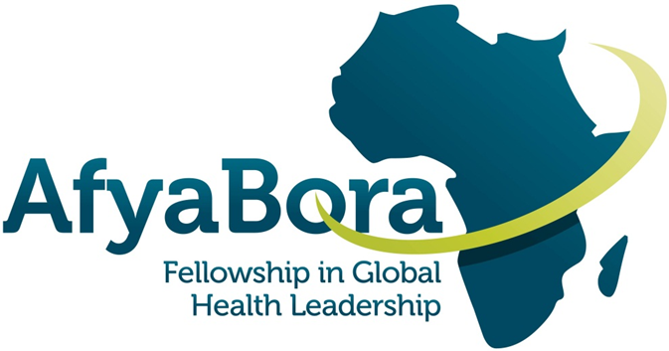

AFYA BORA CONSORTIUM
Research Methods Module

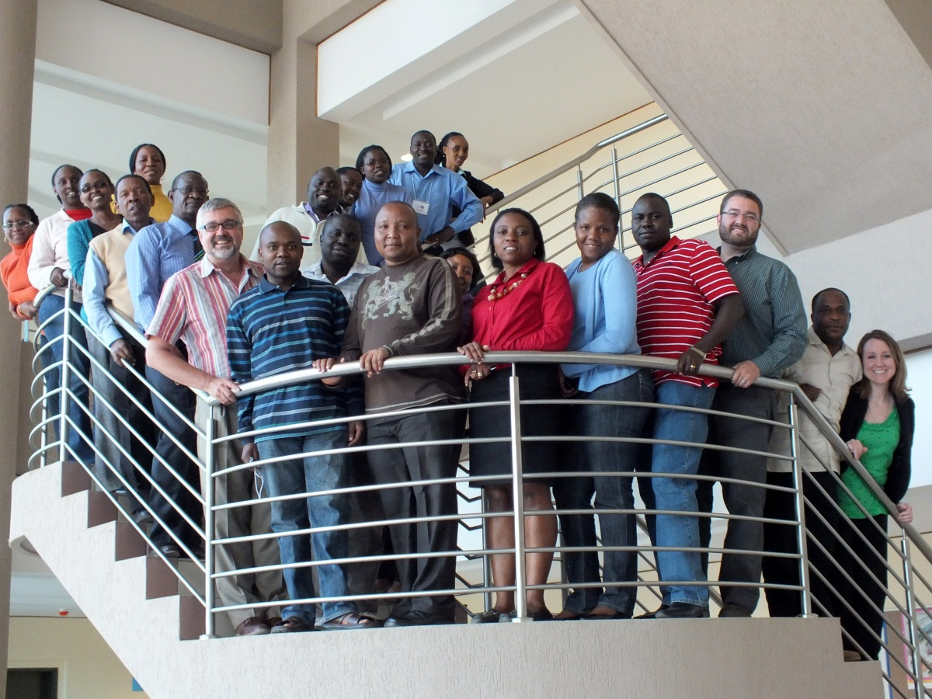

Module Instructors:

Laura Newman, PhD, MHS
Senior Fellow, Department of Global Health
University of Washington
Email: lpnewman@uw.edu

Brandon Guthrie, PhD
Assistant Professor, Departments of Epidemiology and Global Health
University of Washington
Email: bguth@uw.edu

Course Syllabus
Research Methods provides an orientation to the fields of epidemiology and biostatistics for those seeking to conduct research or work on research studies in a global health context. The objective of this course is to provide participants with an understanding of how epidemiologic methods are used to understand the distribution of disease within populations and what factors affect the risk of disease. Through this course, participants will become familiar with the concepts and terminology used to describe disease risk, the common study designs used in epidemiology, the concepts of bias and confounding, and the importance of appropriate measurement in epidemiologic research.

Instructors
Dr. Newman, PhD, MHS, is an epidemiologist and Research Scientist in the Department of Global Health. She is also the Monitoring and Evaluation Coordinator for the Afya Bora Fellowship. Her research interests are in vaccine effectiveness and scale-up in resource-limited settings. Dr. Newman works on a research project based in Nairobi, Kenya that is determining the effectiveness of measles vaccination in HIV-infected children on ART.
Dr. Guthrie, PhD, is an epidemiologist and Assistant Professor of Global Health and Epidemiology at the University of Washington. His specific research interests focus on improving engagement in care among people living with HIV. Dr. Guthrie has NIH-funded research projects based in Nairobi, Kenya that are evaluating interventions to improve linkage and retention in HIV/AIDS care, expedite treatment initiation, and reduce mortality. His research includes both randomized intervention trials as well as mixed methods and implementation science approaches to evaluate interventions that are tailored to achieve both high effectiveness and acceptability.

Expectations and Grading
To be successful in the course you will need to watch the weekly video lectures, read the recommended readings, and complete the weekly quiz. You will need to complete the final exam by the December 13th due date. In order to pass the course, you much have a final score of 70% or higher. Your final score will be calculated as follows:
- Quizzes (40%): You will have only one attempt on each weekly quiz. Your score will be averaged across the 10 quizzes.
- Final exam (40%): The final exam at the end of the course will include multiple-choice questions randomly selected from each topic area and will have 20 questions.
- Writing assignments (15%)
- Discussion forum participation (5%)
For example, if you average 80% on the quizzes and 90% on the final exam and complete all writing and discussion board assignments, your final score will be 88%. If you average 60% on the quizzes and 90% on the final exam and complete all writing and discussion board assignments, your final score will be 80%.

Textbook and Course Materials

Recommended Text
Recommended readings will be drawn from the following texts.
Principles of Epidemiology in Public Health Practice, 3rd Edition. An Introduction to Applied Epidemiology and Biostatistics (Download PDF (Links to an external site.) / Accessible HTML version (Links to an external site.))
Cancer Epidemiology: Principles and Methods. Isabel dos Santos Silva. International Agency for Research on Cancer. Lyon. 1999. (Download PDF (Links to an external site.))

Topic Outline
Week 1: Introduction to Epidemiologic Methods and Quantitative Research
Week 2: Introduction to Statistical Decision Making
Week 3: Epidemiologic Study Designs
Week 4: Causation, Bias, and Confounding
Week 5: Measurement, Classification, and Misclassification
Week 6: Interpretation of Epidemiologic Studies and Decision Making
Week 7: Multiple Variable Regression Models in Epidemiology
Week 8: Data Management Practices in Health Research
Week 9: Qualitative Research Methods
Week 10: Analyzing Qualitative Data and Public Health Applications

Quiz and Conference Schedule:

 | Lecture | Quiz Due Date | Conference  Session  Group 1  (Tuesday) | Conference Session Group 2  (Wednesday)
1 | Introduction to Epidemiologic Methods and Quantitative Research | October 25 | November 3 | November 4
2 | Introduction to Statistical Decision Making | November 1
3 | Epidemiologic Study Designs | November 8 | November 17 | November 18
4 | Causation, Bias, and Confounding | November 15
5 | Measurement, Classification, and Misclassification | November 22 | December 1 | December 2
6 | Interpretation of Epidemiologic Studies and Decision Making | November 29
7 | Multiple Variable Regression Models in Epidemiology | December 6 | December 15 | December 16
8 | Data Management Practices in Health Research | December 13
9 | Qualitative Research Methods | December 20 | Tuesday January 5  (Groups 1 and 2 combined)
10 | Analyzing Qualitative Data and Public Health Applications | January 3
 | FINAL EXAM DUE | January 10 | none
*Course instructors will be available via Canvas Conference (instructions to follow) bi-weekly on either Tuesdays or Wednesdays @ 9:30AM PST/ 8:30PM EAT to discuss the previous week’s content and quiz. We have split your cohort into two groups, as listed below; please attend the conference day that corresponds to your group.

Canvas Conference Group Assignments
Group 1 (Tuesday) | Group 2 (Wednesday)
Bayengemali Munyere | Miriam Sebego
Drusilla Makworo | Ogechi James
Edward Kumakech | Paul Mashauri
Elizabeth O'Hara | Phillip Gitta
Evaline Lang 'at | Rache Mureau-Haines
Irene Biraro-Seguya | Samuel Ng'arng'ar
Joel Njah | Shally Mwashemele
Lilian Mbau | Stella Muyanja
Magdalena Lyimo | Stephen Kishinhi
Malebogo Pusoentsi | Wame Dikobe

